Project 02 – Networks
CNN – CS6301.502 – Kapil Gautam

Section 1 – Design

- Include 3 figures (either drawn by hand or in a drawing program)
- The network structure

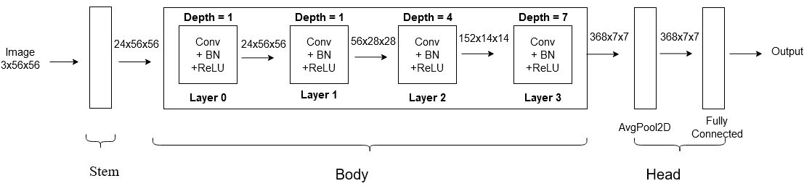

- The network standard building block

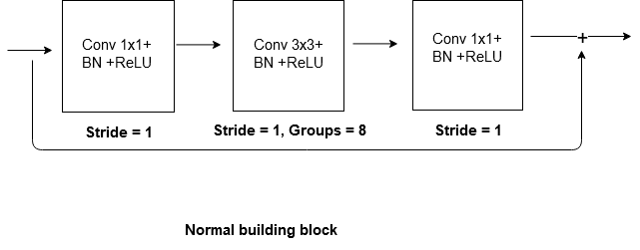

- The network down sampling building block

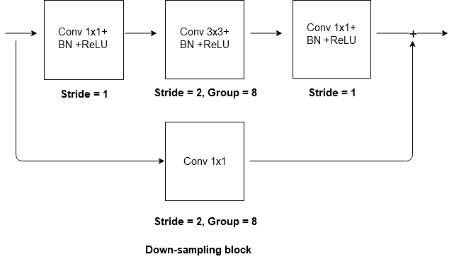
- Include 1 table

    - Describes the parameters (e.g., channels, groups, repeats, …) to create RegNetX-200MF from the generic network structure, standard building block and down sampling building block

Layer name | Output size | Stride | RegNetX-200MF
stem | 56x56 | 1 | 3x3,24, s=1
enc_0 (Layer 0, depth=1, channel=24) | 56x56 | 1 | 1x1,24, s=1  3x3,24, s=1, g=8  1x1,24, s=1
enc_1 (Layer1, depth=1, channel=56) | 28x28 | 2 | 1x1,24, s=1  3x3,24, s=2, g=8  1x1,56, s=1
enc_2 (Layer2, depth=4, channel=152) | 14x14 | 2 | 1x1,56, s=1  3x3,56, s=2, g=8 x4  1x1,152, s=1
enc_3 (Layer3, depth=7, channel=368) | 7x7 | 2 | 1x1,152, s=1  3x3,152, s=2, g=8 x7  1x1,368, s=1
dec (Head) | 1x1 | - | AvgPool, 100-d fc, Softmax

Section 2 – Training
- Include 1 table
      - All hyper parameters and associated values

DATA_BATCH_SIZE | 256
DATA_MEAN | (0.485, 0.456, 0.406)
DATA_STD_DEV | (0.229, 0.224, 0.225)
SEED | 42
TRAINING_LR_MAX | 0.01
TRAINING_LR_INIT_SCALE | 0.1
TRAINING_LR_INIT_EPOCHS | 3
TRAINING_LR_FINAL_SCALE | 0.1
TRAINING_LR_FINAL_EPOCHS | 23
TRAINING_NUM_EPOCHS | 3+23 = 26
TRAINING_LR_INIT | 0.01*0.1 = 0.001
TRAINING_LR_FINAL | 0.01*0.1 = 0.001
optimizer | Adam
optimizer betas | 0.9, 0.999
optimizer eps | 1e-08
optimizer weight_decay | 0

- Include 2 plots

- Training data loss vs epoch

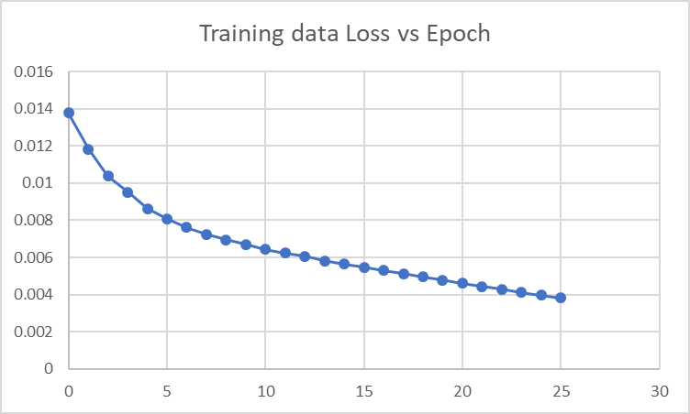

- Testing data accuracy vs epoch

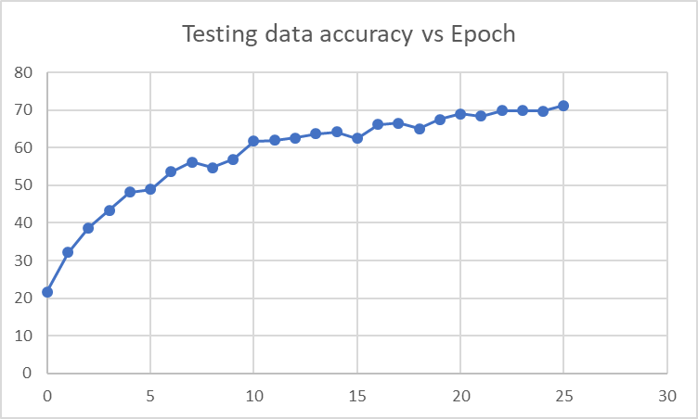

- List the final accuracy
71.24%

Section 3 – Implementation

- Include 1 table

- A list of each CNN style 2D convolution operator and associated the number of MACs and parameters; at the bottom of the table put a sum for the whole network

Layer | Parameters | Input | Output | MAC
stem | 648 | 3x56x56 | 24x56x56 | 2,032,128
enc_0.0 – conv1 | 576 | 24x56x56 | 24x56x56 | 1,806,336
enc_0.0 – conv2 (G=8, S=1) | 648 | 24x56x56 | 24x56x56 | 2,032,128
enc_0.0 – conv3 | 576 | 24x56x56 | 24x56x56 | 1,806,336
enc_1.0 – conv0 (G=8, S=2) | 168 | 24x56x56 | 56x28x28 | 131,712
enc_1.0 – conv1 | 576 | 24x56x56 | 24x56x56 | 1,806,336
enc_1.0 – conv2(G=8, S=2) | 648 | 24x56x56 | 24x28x28 | 508,032
enc_1.0 – conv3 | 1344 | 24x28x28 | 56x28x28 | 1,053,696
enc_2.0 – conv0(G=8, S=2) | 1064 | 56x28x28 | 152x14x14 | 208,544
enc_2.0 – conv1 | 3136 | 56x28x28 | 56x28x28 | 2,458,624
enc_2.0 – conv2(G=8, S=2) | 3528 | 56x28x28 | 56x14x14 | 691,488‬
enc_2.0 – conv3 | 8512 | 56x14x14 | 152x14x14 | 1,668,352
enc_2.1 – conv1 | 23104 | 152x14x14 | 152x14x14 | 4,528,384‬
enc_2.1 – conv2(G=8, S=1) | 25992 | 152x14x14 | 152x14x14 | 5,094,432‬
enc_2.1 – conv3 | 23104 | 152x14x14 | 152x14x14 | 4,528,384
enc_2.2 – conv1 | 23104 | 152x14x14 | 152x14x14 | 4,528,384
enc_2.2 – conv2(G=8, S=1) | 25992 | 152x14x14 | 152x14x14 | 5,094,432
enc_2.2 – conv3 | 23104 | 152x14x14 | 152x14x14 | 4,528,384
enc_2.3 – conv1 | 23104 | 152x14x14 | 152x14x14 | 4,528,384
enc_2.3 – conv2(G=8, S=1) | 25992 | 152x14x14 | 152x14x14 | 5,094,432
enc_2.3 – conv3 | 23104 | 152x14x14 | 152x14x14 | 4,528,384
enc_3.0 – conv0(G=8, S=2) | 6992 | 152x14x14 | 368x7x7 | 342,608‬
enc_3.0 – conv1 | 23104 | 152x14x14 | 152x14x14 | 4,528,384
enc_3.0 – conv2(G=8, S=2) | 25992 | 152x14x14 | 152x7x7 | 1,273,608‬
enc_3.0 – conv3 | 55936 | 152x7x7 | 368x7x7 | 2,740,864‬
enc_3.1 – conv1 | 135424 | 368x7x7 | 368x7x7 | 6,635,776
enc_3.1 – conv2(G=8, S=1) | 152352 | 368x7x7 | 368x7x7 | 7,465,248‬
enc_3.1 – conv3 | 135424 | 368x7x7 | 368x7x7 | 6,635,776
enc_3.2 – conv1 | 135424 | 368x7x7 | 368x7x7 | 6,635,776
enc_3.2 – conv2(G=8, S=1) | 152352 | 368x7x7 | 368x7x7 | 7,465,248‬
enc_3.2 – conv3 | 135424 | 368x7x7 | 368x7x7 | 6,635,776
enc_3.3 – conv1 | 135424 | 368x7x7 | 368x7x7 | 6,635,776
enc_3.3 – conv2(G=8, S=1) | 152352 | 368x7x7 | 368x7x7 | 7,465,248‬
enc_3.3 – conv3 | 135424 | 368x7x7 | 368x7x7 | 6,635,776
enc_3.4– conv1 | 135424 | 368x7x7 | 368x7x7 | 6,635,776
enc_3.4 – conv2(G=8, S=1) | 152352 | 368x7x7 | 368x7x7 | 7,465,248‬
enc_3.4 – conv3 | 135424 | 368x7x7 | 368x7x7 | 6,635,776
enc_3.5 – conv1 | 135424 | 368x7x7 | 368x7x7 | 6,635,776
enc_3.5 – conv2(G=8, S=1) | 152352 | 368x7x7 | 368x7x7 | 7,465,248‬
enc_3.5 – conv3 | 135424 | 368x7x7 | 368x7x7 | 6,635,776
enc_3.6 – conv1 | 135424 | 368x7x7 | 368x7x7 | 6,635,776
enc_3.6 – conv2(G=8, S=1) | 152352 | 368x7x7 | 368x7x7 | 7,465,248‬
enc_3.6 – conv3 | 135424 | 368x7x7 | 368x7x7 | 6,635,776
dec | 36800 | 368x7x7 | 368x1x1 | 135,424
Total | 2926048 |  |  | 7,676,928 ‬+ 3,499,776+ 47,480,608 + 133,441,688 = 192,099,000‬

